1. **Use the pumping lemma to prove that the language is not context free.**

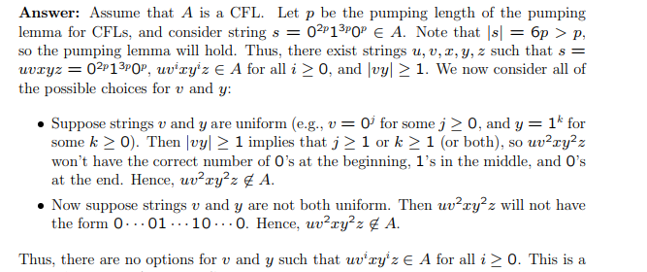



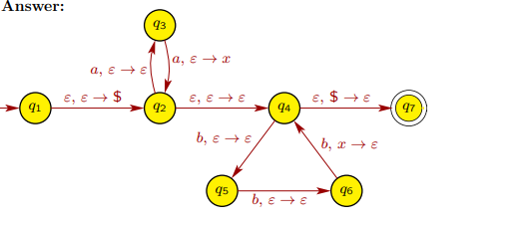

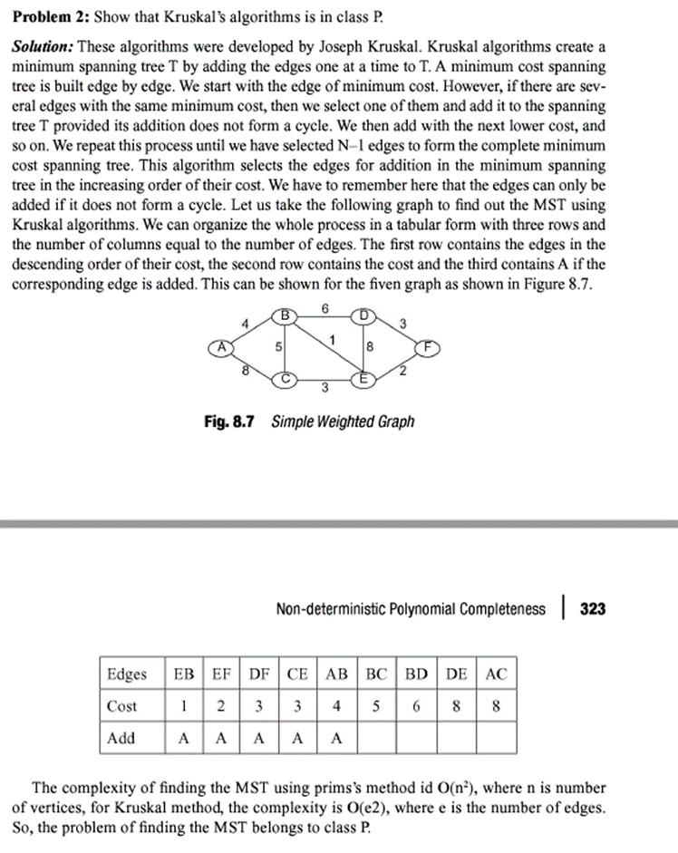

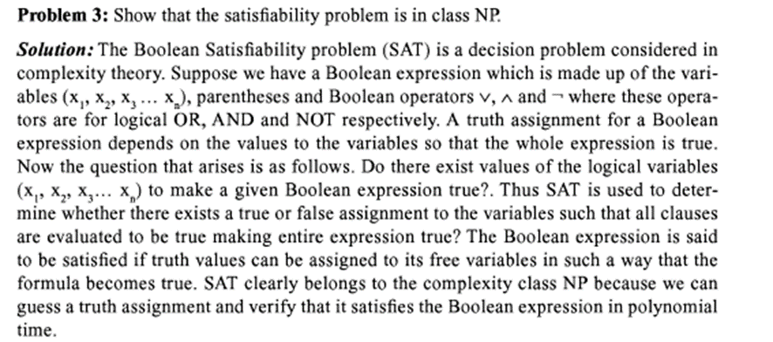

**4. Construct a Turing machine that accepts all input in the following format: number of A’s (at least 1) followed by number of B’s (at least 1). Draw the transition diagram; write the instantaneous description and the transition function. Also give the tuple Notation for the designed TM.**

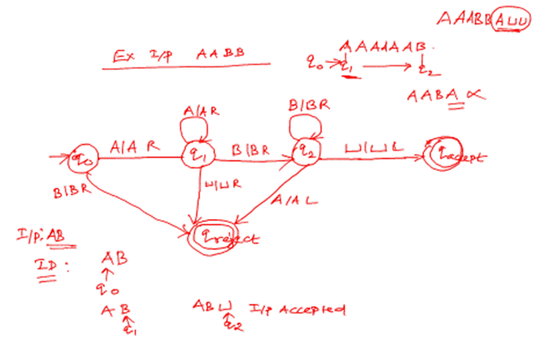

**5. Construct a Turing machine to perform function f(x) = x2**

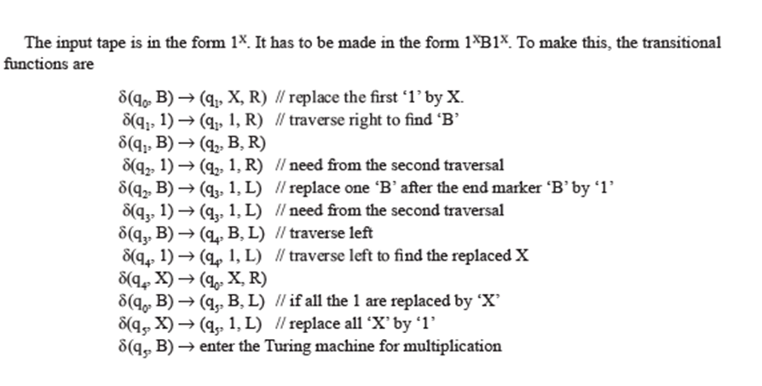

**6. Design a Turing Machine to compute 1's complement**

**Approach:**

**1. Scanning input string from left to right**

**2. Converting 1’s into 0’s**

**3. Converting 0’s into 1’s**

**4. Move the head to the start when BLANK is reached.**

**Steps:**

**· Step-1. Convert all 0’s into 1’s and all 1’s into 0’s and go right if B found go to left.**

**· Step-2. Then ignore 0’s and 1’s and go left & if B found go to right**

**· Step-3. Stop the machine.**

**7.**

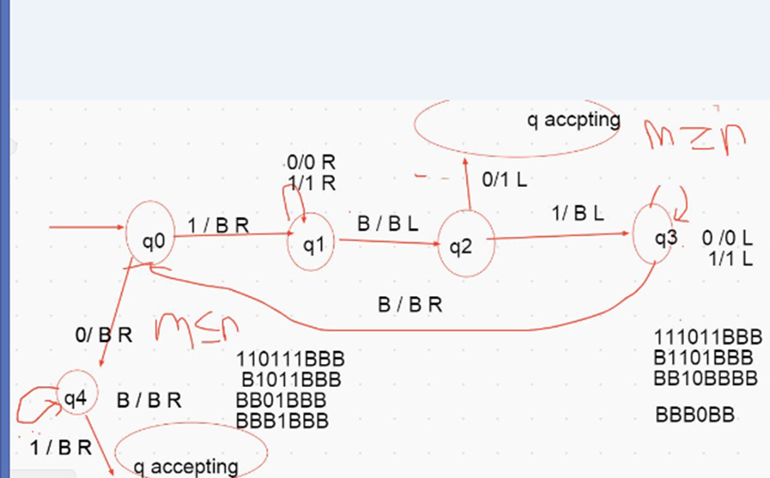

**7. Show that the following post correspondence problem has a solution and if so give the solution.**

| **i** | **List A**  **Wi** | **List B**  **Xi** |
| --- | --- | --- |
| **1** | **11** | **111** |
| **2** | **100** | **001** |
| **3** | **111** | **11** |

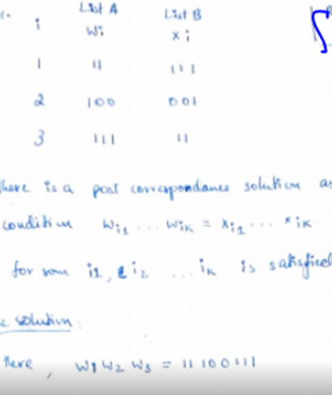

**8.** .Do phrase structure analysis of the following sentences

The dog saw a man in the park

